**To check the current Angular version on browser console:**

**getAllAngularRootElements()[0].attributes["ng-version"];**

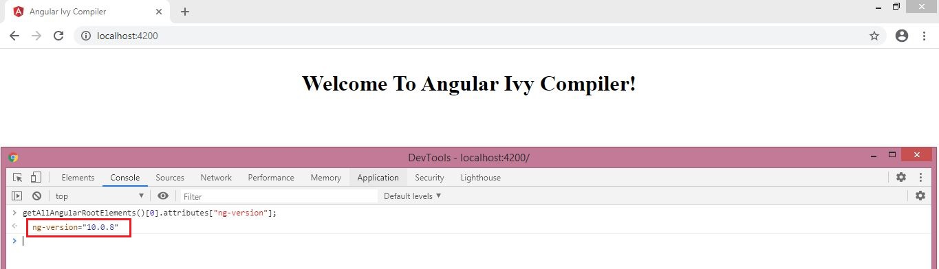

You can also open the **Console** and go to the Elements tab on the **DevTools** of whatever browser you use:

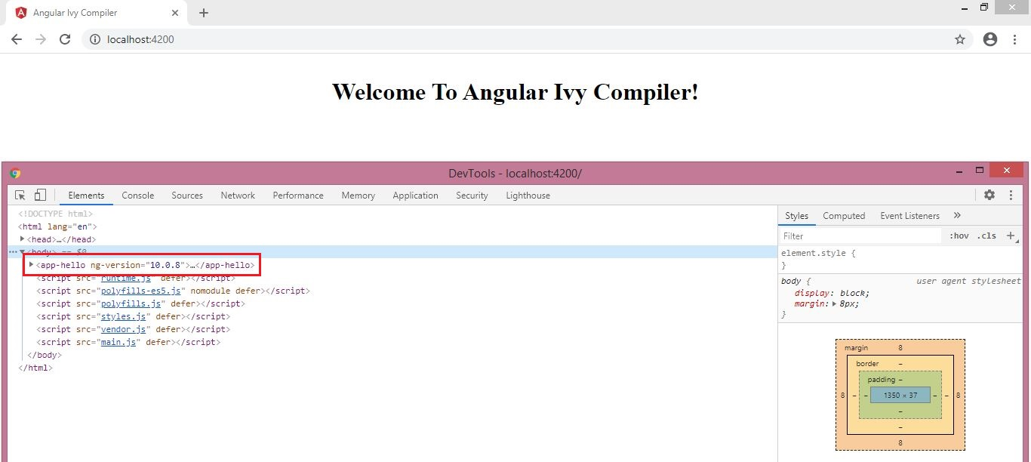

**To check the current Angular version at cmd/Git Bash:**

